**FINAL REPORT**

**FOR**

**COUNTRIES LIST**

**PREPARED BY**

**KUNJAN PATEL**

**ALEXANDER PINTO**

**SHERIDAN COLLEGE**

**OVERVIEW**

The purpose of this application is to provide users the information needed to understand the background of each country. This application allows the user to select a certain Continent and a certain Country within that selection. An Add button will be given to the user on each page to allow them to add more information to the application that was missing. Once a Country is selected the application will show an image of the country and information on the side of the image. As well the user will be given a comment box to all the user to input more information about the country or even add personal experience they had with the Country.

**APPLICATION WINDOWS**

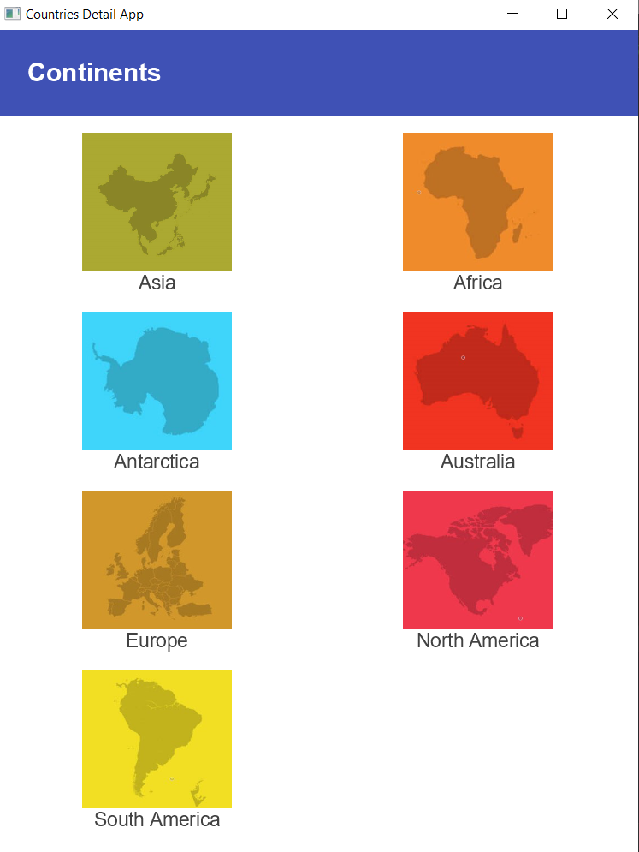

Fig 1.1 Main continent page

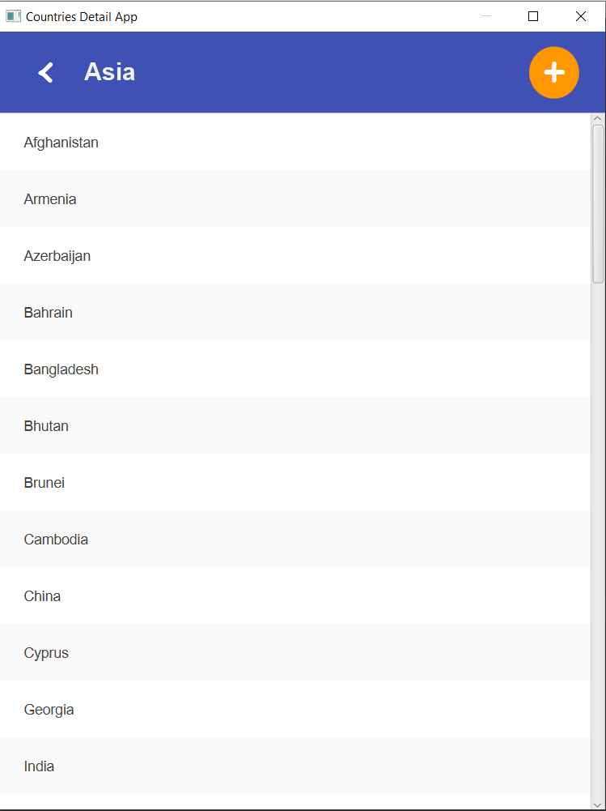

Fig 1.2 List of countries page

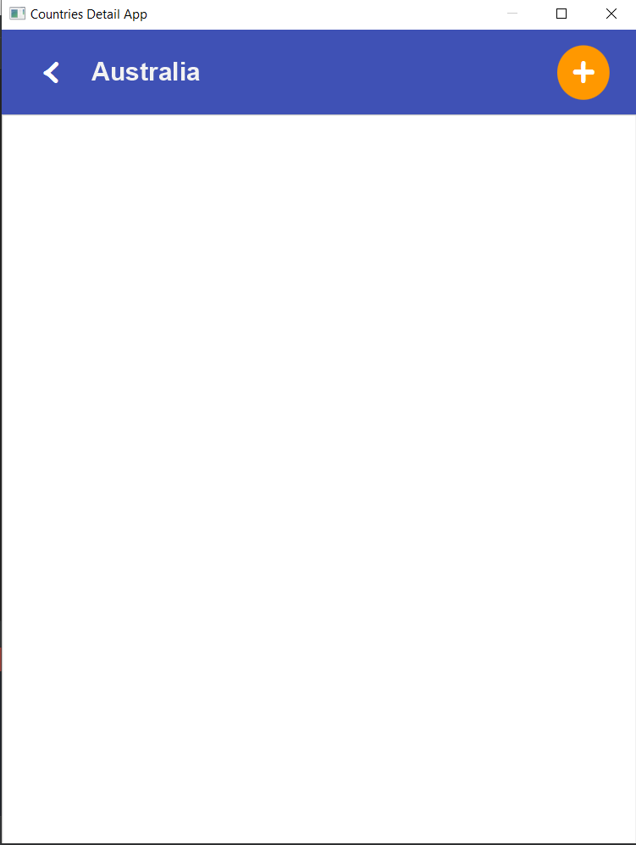

Fig 1.3 Initial empty list of countries

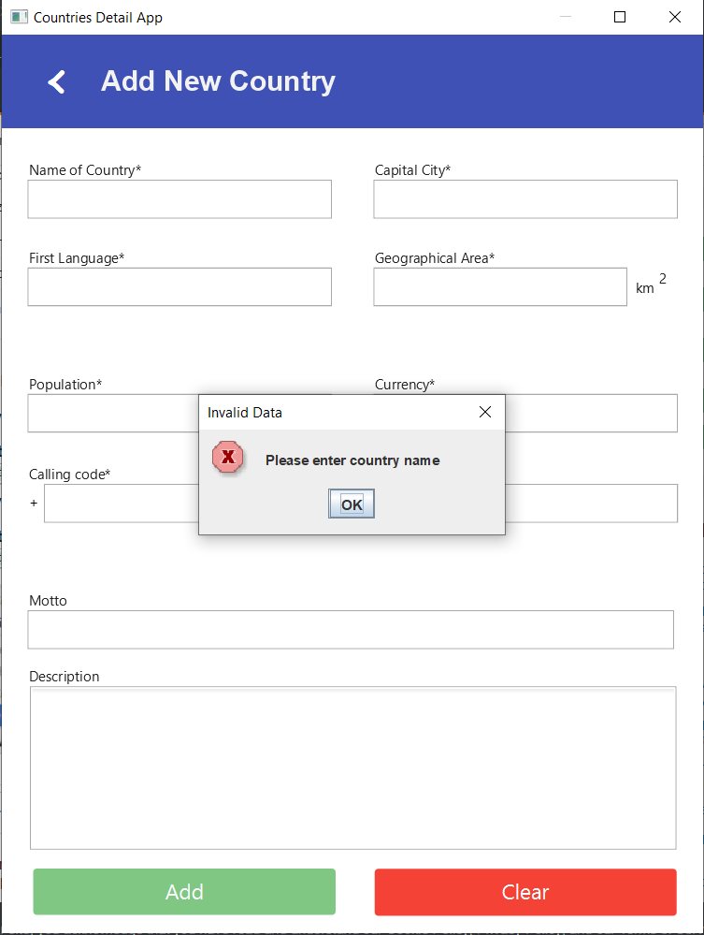

Fig 1.4 Add country form validation

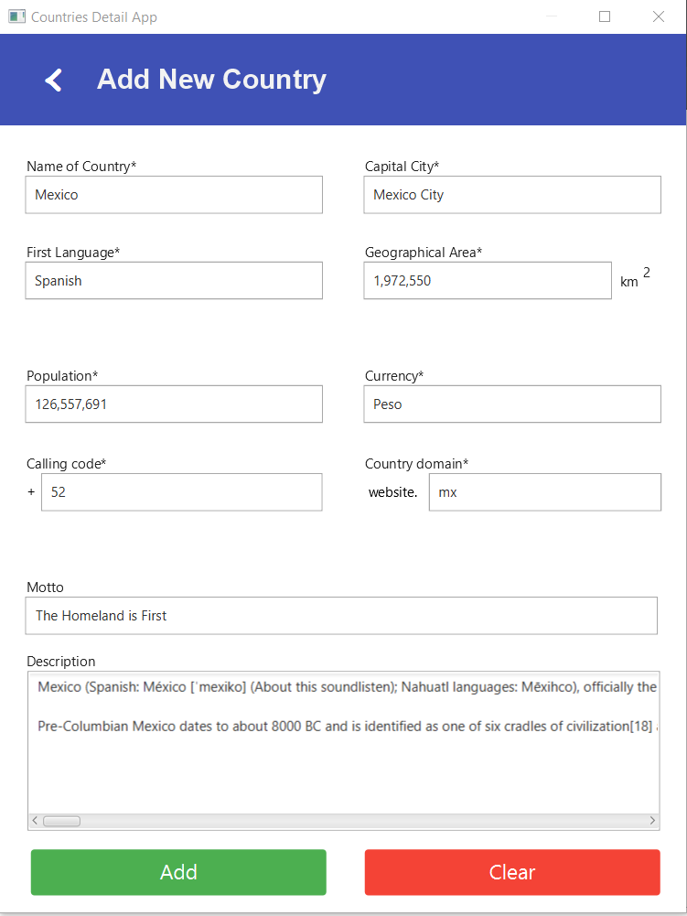

Fig 1.5 Add country filled form

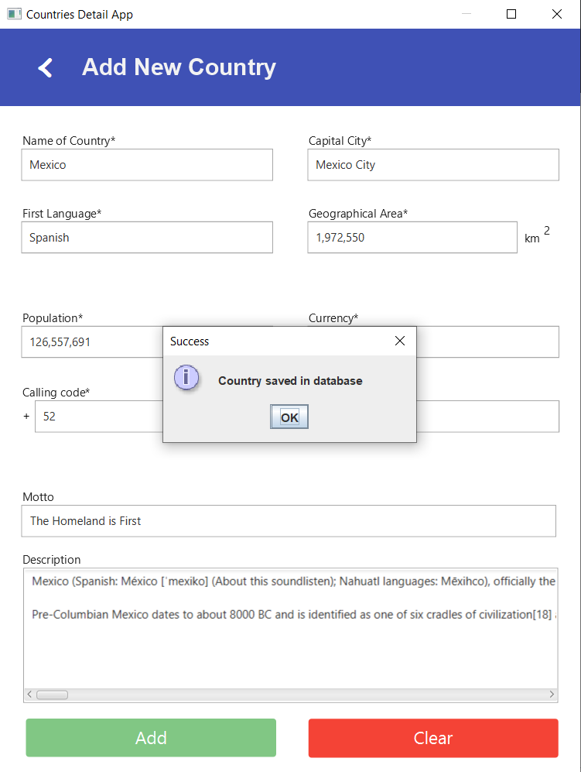

Fig 1.6 Successfully saved country message

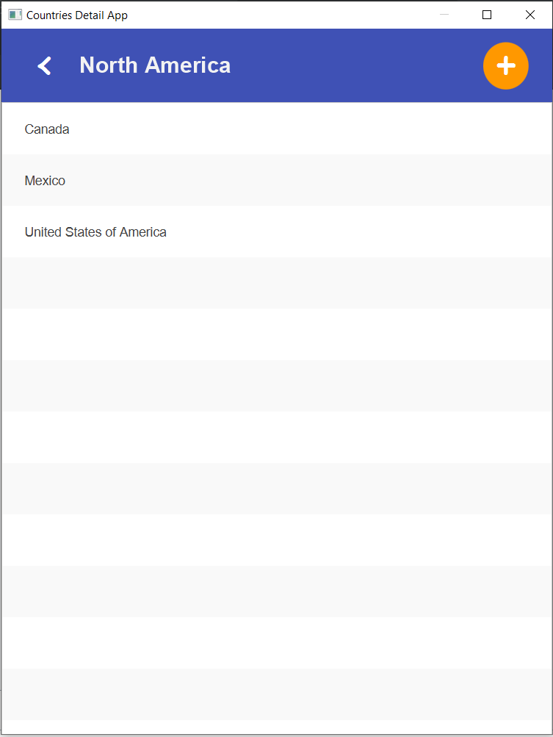

Fig 1.7 updated list of countries after saving in records

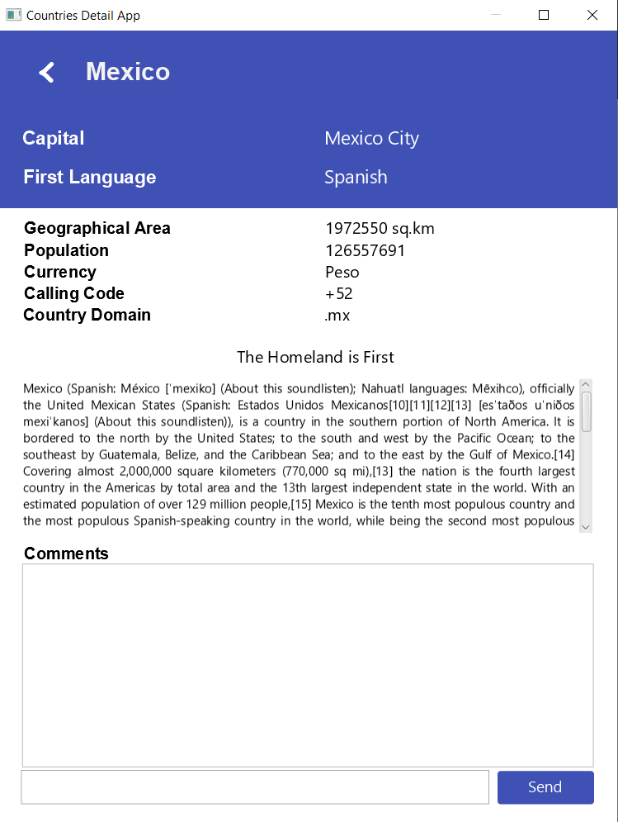

Fig 1.7 Country information page

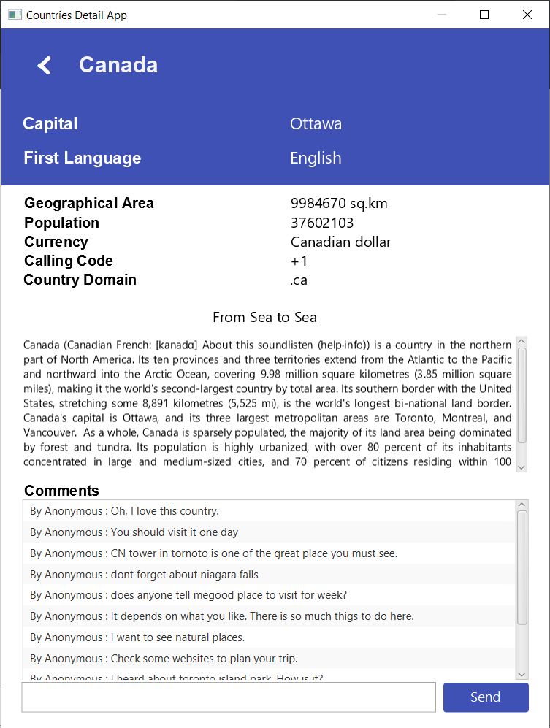

Fig 1.8 Country information with comments

**UML DIAGRAMS**

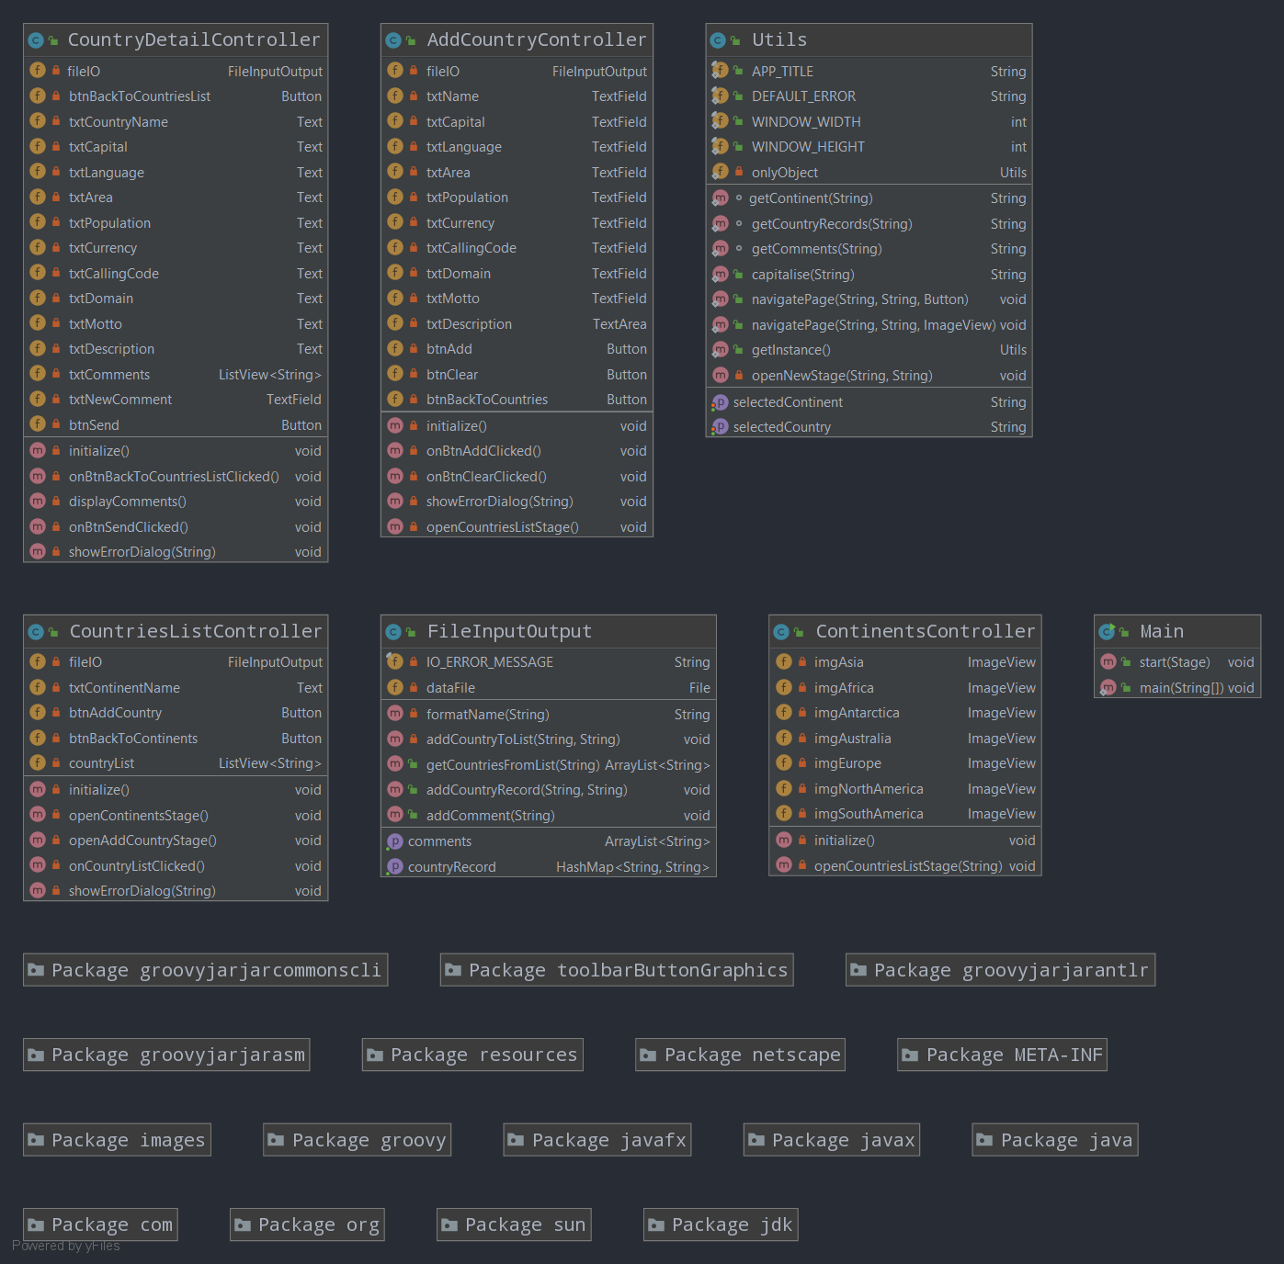

Final UML Diagram for countries app

**CONCLUSION**

The project concluded by each team member as mention below.

* **Alexander Pinto**

Some important lessons learned was making sure comments are always implemented as this Final Project was a group project and understanding the difference between Printer writer and buffered writer. A couple of difficulties I have encountered was I kept forgetting to create an object to be able to complete a couple of the methods and as well showing the information from the file.

* **Kunjan Patel**

Most difficult part for me is to manage structure of data stored in files to retrieve and format it properly so files act as virtual database. The structure of project helped me to manage code properly and design code structurally. Moreover designing separate utils class and file operation help to centralise common feature and follows MVC pattern.